# Ideation Phase Empathize & Discover

|  |  |  |  |
| --- | --- | --- | --- |
|  | NM ID | BF65628C5F4C176991E4180F64CA6B6F |  |
|  | Project Name | How To Create Brand Name, Brand Mail And Brand Logo In Canva. |  |

Empathy Map Canvas:

# An empathy map is a visual tool or framework used in design thinking and customer-centered design processes to help teams gain a deeper understanding of their target audience or users. It encourages designers, marketers, or product developers to step into the shoes of their users, enabling them to better empathize with their thoughts, feelings, needs, and behaviors. Empathy maps are typically used to create a shared understanding of users and their perspectives among team members.

Empathy map:

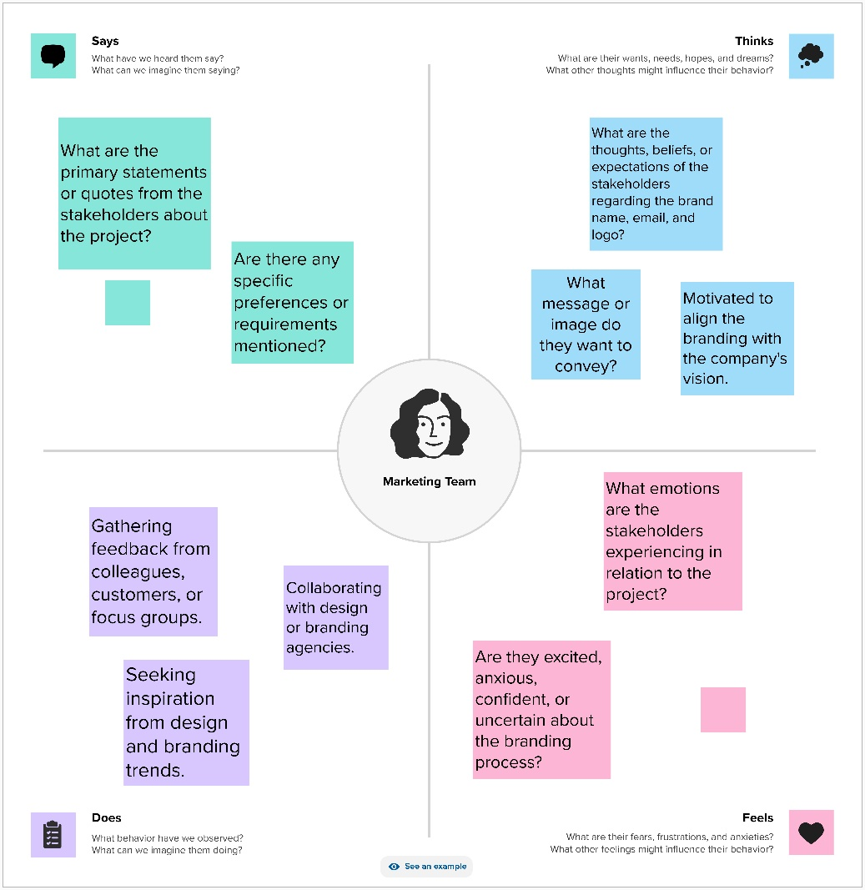

Reference link:

<https://app.mural.co/t/createbrandnamebrandemailand2105/m/createbrandnamebrandemailand2105/1698771493362/fe53d0a9e0e65852603a19183673be99f2d61443?sender=ud4ffd83549e2b2a63c108160>